ST.XAVIER’S COLLEGE

**Maitighar, Kathmandu**



**DBMS LAB ASSIGNMENT**

**Submitted By:**

**Narayan Panthi**

013BSCCSIT024

**Submitted To:**

**Er. Sanjay Kumar Yadav** ………..…………….

**Lecturer**

**Department of Computer Science**

**Date of Submission:- *2015 -*** *__****_-*** *___*

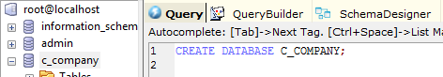

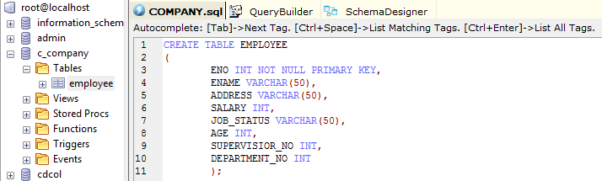

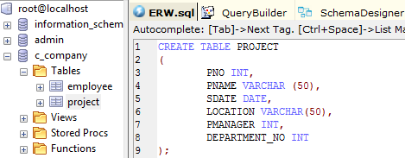

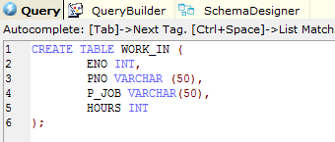

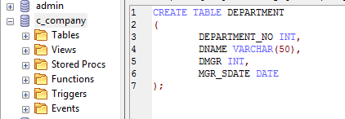

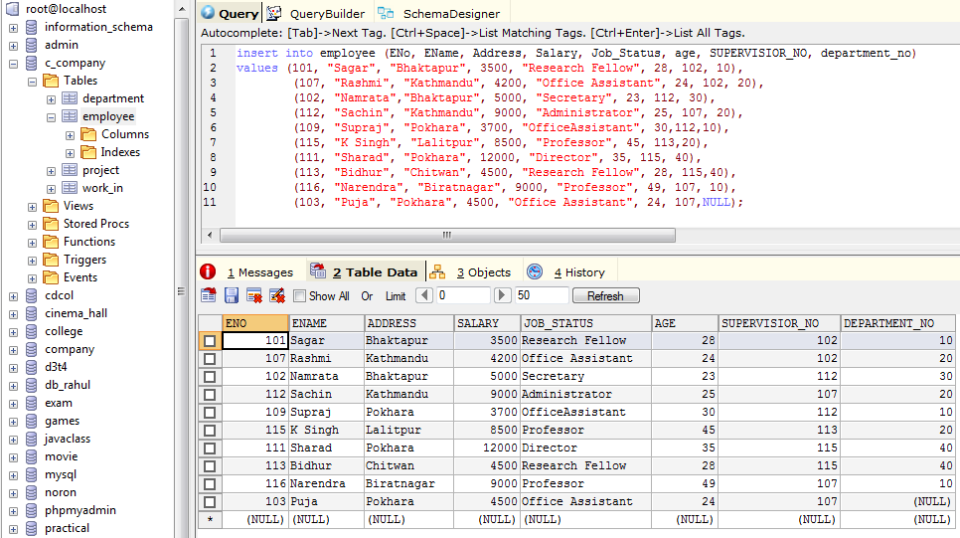  
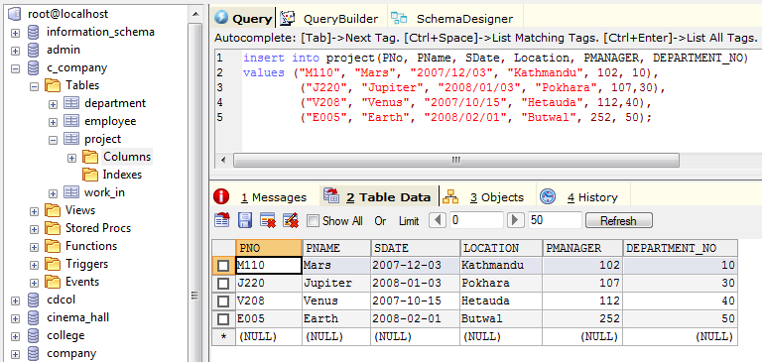

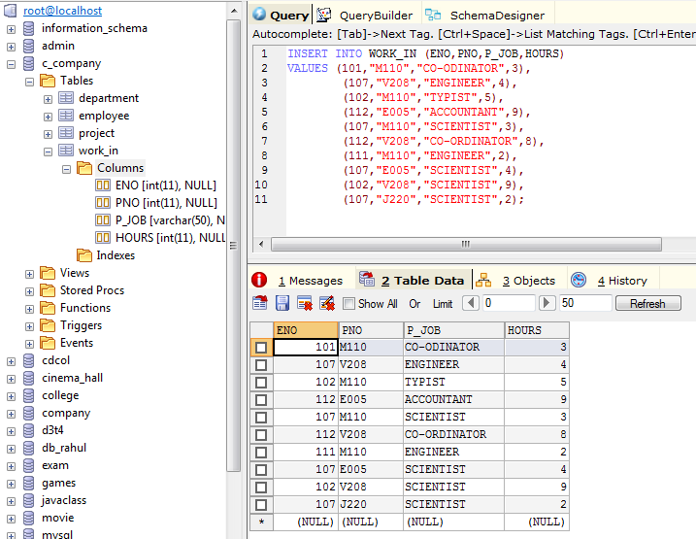

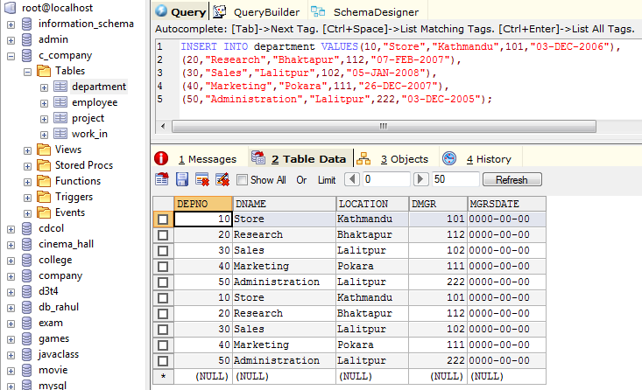

Question: Find the Eno, Ename of the employee whose salary is >4000.

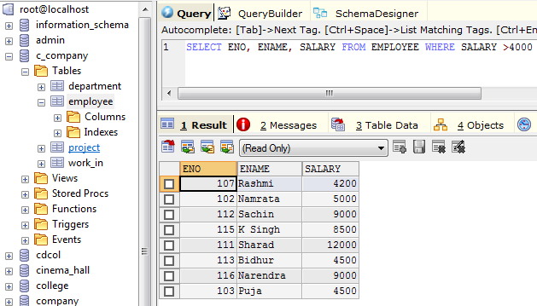

Combining Condition and Boolean operation.

Question: Find the Eno, Ename, Salary of the employee whose salary is >5000 and job_status is professor.

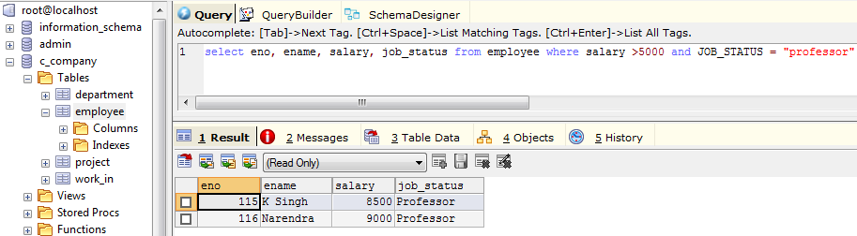

Removing duplicates

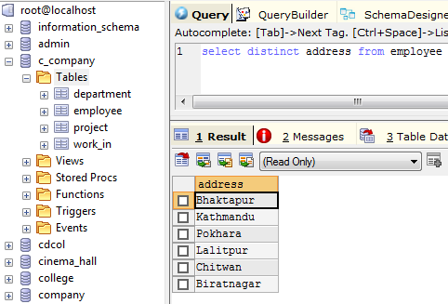

Find the Eno, Ename, Salary, of the employee whose department_no is 20 or job_status is research fellow.

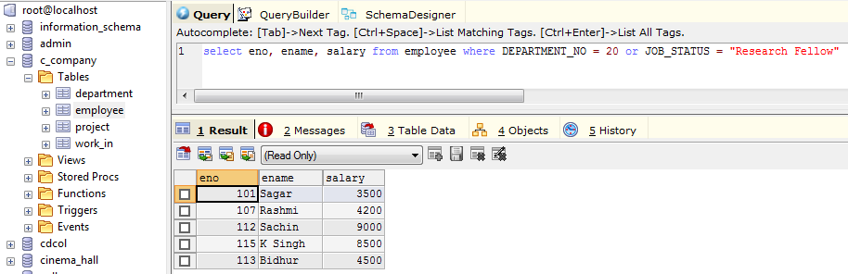

Range Specification (from and between ) where condition1 between 30 and 40.

Question: Find the Eno, Ename, Age and salary from the employee where the age is between 24 and 28.

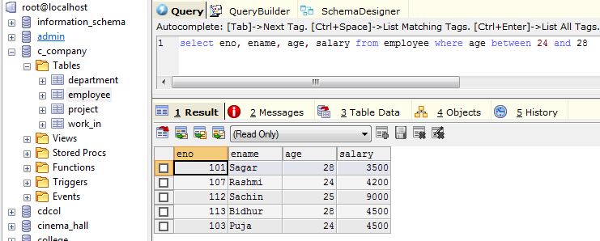

String Operation (like keyword and % symbol )

‘ABC%’: All string that starts with “ABC” example: ABCS, ABCR, etc.

‘%XYZ’: All string that ends with “XYZ” example: AXYZ, MNOXYZ etc.

‘%AN%’: All string that contain the pattern ‘AN’ anywhere. example RAMAYAN, NARAYAN etc.

Question: Find Eno, Ename, whose starting letter is “SA”.

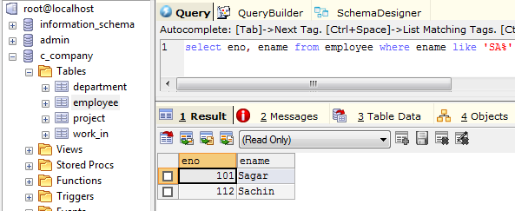

Questions :

List all employee names with their project name.

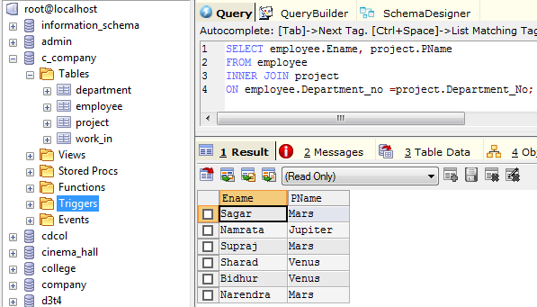

List name of all employee and their salary who are working in project MARS or VENUS.

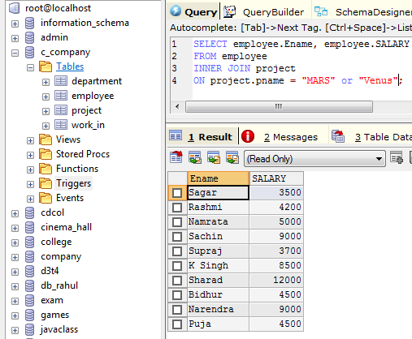

List name of all employee and their salary who are working in EARTH and VENUS.

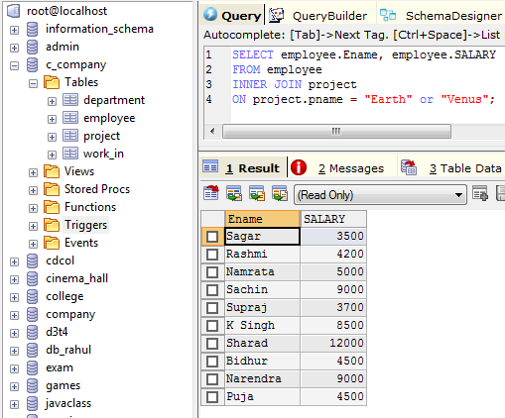

List name and address of all employee who are working in department which is located in pokhara.